H.T No
Regulations:
A19

Sreenidhi Institute of Science and Technology
(An Autonomous Institution)
Code No: 7W103 Date: 28-Oct-2021 (FN)

M.Tech I-Year I-Semester External Examination, Oct/Nov - 2021 (Supplementary)
ADVANCED MECHANICS OF SOLIDS (CADCAM)

Time: 3 Hours Max.Marks:70

Note: a) No additional answer sheets will be provided.
b) All sub-parts of a question must be answered at one place only, otherwise it will not be valued.
c) Missing data can be assumed suitably.

ANSWER ANY 5 OUT OF 8 QUESTIONS. EACH QUESTION CARRIES 14 MARKS.

Bloom's Cognitive Levels of Learning (BCLL)

Remember | L1 | Apply | L3 | Evaluate | L5
Understand | L2 | Analyze | L4 | Create | L6

 |  |  | BCLL | CO(s) | Marks
1. | a) | Using Castigliano's second theorem, determine the reaction of the vertical support C of the structure shown (Fig. 1 ). Beam ACB has Young's modulus E and member CD has a value E'. The cross-sectional area of CD is a.  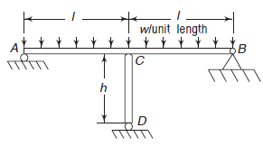  Figure. 1 | L4 | CO1 | [7M]
 | b) | For the cantilever of total length L shown in Fig. 2, determine the deflection at end A. Neglect shear energy  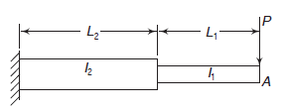  Figure.2 | L5 | CO1 | [7M]
2. |  | Determine the location of shear centre for the channel section in the fig.3 shown below  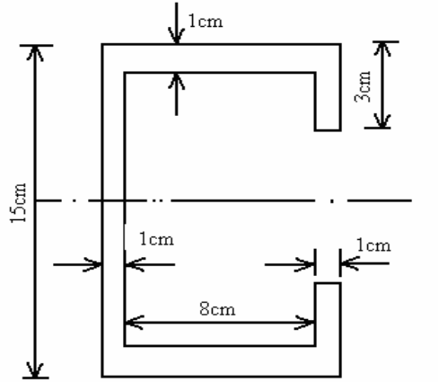  Figure.3 | L5 | CO2 | [14M]
3. |  | A railroad uses steel rails (E =200GPa) with a depth of 184 mm. The distance from the top of the rail to its centroid is 9.91mm, and the moment of inertia of the rail is 36 .9 x 10⁶ mm⁴. The rail is supported by ties, ballast and a road bed that together are assumed to act as an elastic foundation with spring constant K = 14.0 N/mm². Determine the maximum deflection, maximum bending moment and maximum flexural stress in the rail for a single wheel load of 170KN. | L5 | CO3 | [14M]
4. |  | The aluminium (G=27GPa) hollow thin walled torsion member has dimensions as shown in fig.4. Its length is 3m. If the member is subjected torque of 11KN-m, determine the maximum shear stress and angle of twist.  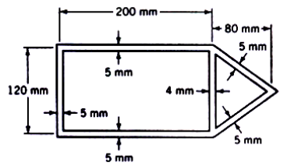  Figure 4 | L5 | CO4 | [14M]
5. |  | The deflection curve for a pin-ended column is represented by a polynomial as y = ax⁴ + bx³ + cx² + dx + e  Determine the critical load by the energy method. | L5 | CO5 | [14M]
6. |  | A small internal through thickness crack of 10mm is present in a large plate. Remote stress of 2000MPa is applied as shown in fig.5. calculate the K_{I} value.  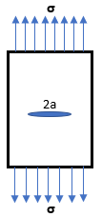  Figure 5 | L5 | CO6 | [14M]
7. | a) | Derive the expression for elastic energy due to shear forces. | L5 | CO1 | [5M]
 | b) | Explain the procedure to find shear centre for a channel sections. | L3 | CO2 | [5M]
 | c) | State the assumptions and limitations in Winkler Bach theory for curved beams. | L2 | CO3 | [4M]
8. |  | Derive expressions for i) Angle of twist per unit length  ii) Torsional rigidity and  iii) Stresses, for elliptical cross section under torsion, by Prandtl’s method? | L5 | CO4 | [14M]
-- 00 -- 00 –

